**Installation Guide**

In order to access the website the user needs to have a functioning web browser and operating system installed on their computer machine.

1. **For Personal Computers/desktops/laptops:**

In order to access the judgy web-app:

1. Open the web browser. The default web browsers for some of the most popular operating systems are:
   1. Windows 10: Microsoft edge
   2. Windows 7: Internet explorer
   3. Mac OS: Safari

Other popular third-party cross-platform web browsers are Google Chrome and Mozilla Firefox.

1. Enter the following URL in the search bar and press enter:

<https://alexmlen.github.io/Judgy/#/>

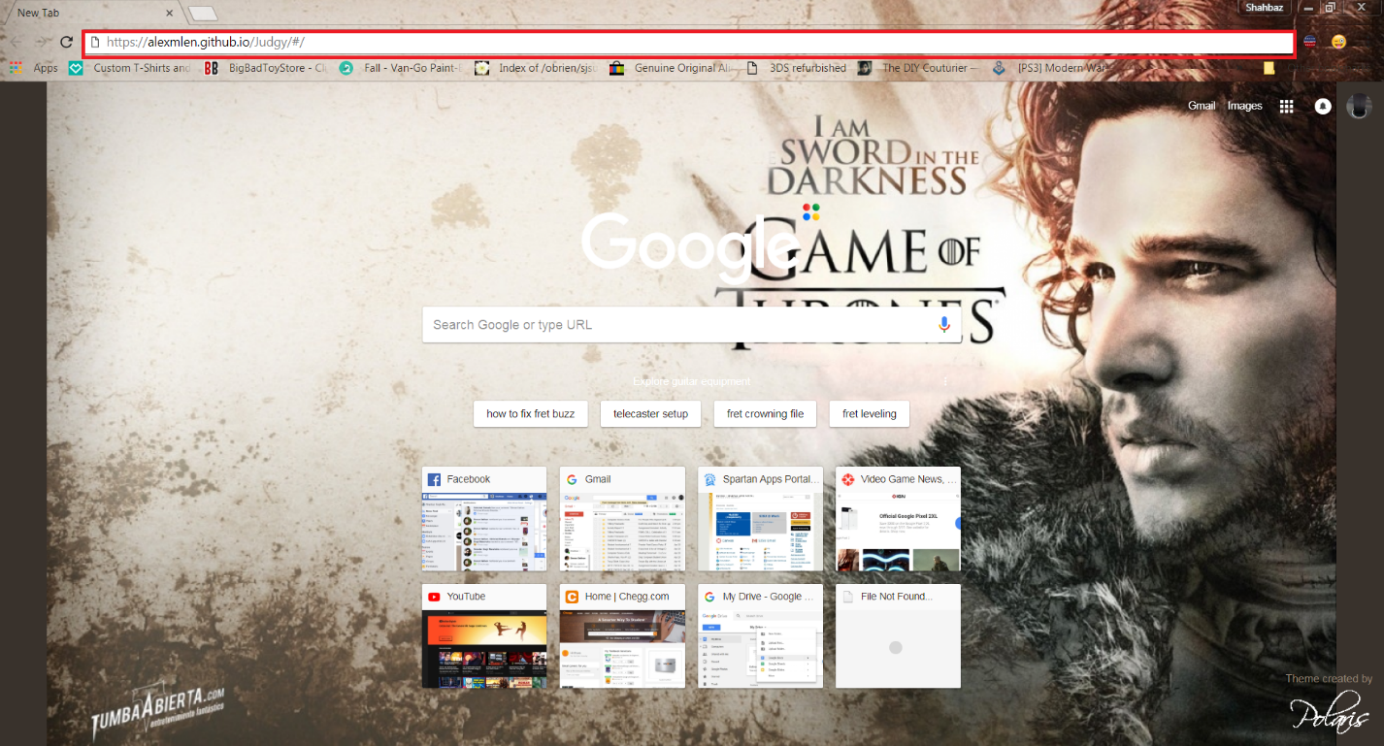

Figure 1: The above picture shows the search bar highlighted in a red box as placed on the google chrome chrome browser. Other web browser should have a similar search bar for navigating the internet.

1. Proceed to sign up for Judgy and validate your account. You could skip the sign up procedure and use the following credentials to sign in to the Judgy platform for testing purposes:

Email Address: [shahbaz.mansahia@sjsu.edu](mailto:shahbaz.mansahia@sjsu.edu)

Password: element115

1. Enjoy the using “Judgy”, the cutting edge application for contest creation, judgement and participation!
2. **For Mobile Operating Systems:**
3. Open the web browser. The default web browsers for some of the most popular mobile operating systems are:

Android OS: Chrome

iOS : Safari

1. Enter the following URL in the search bar and press enter:

<https://alexmlen.github.io/Judgy/#/>



Figure 2: The above picture shows the chrome browser on a mobile phone running android OS highlighted in a red box.

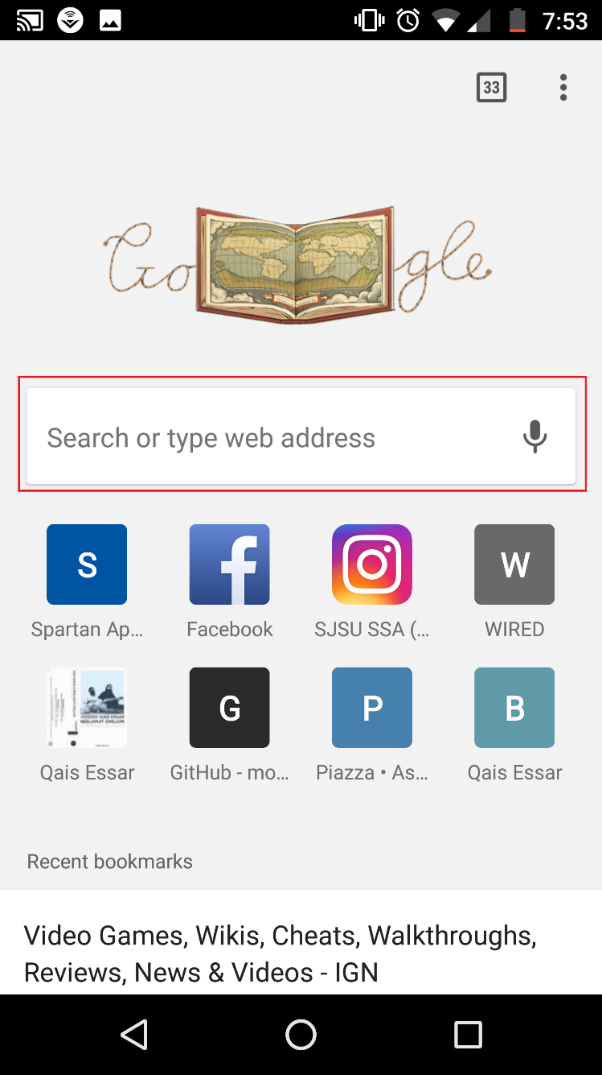

Figure 3: The above picture shows the search bar in the Chrome application on Android OS highlighted in a red box.

1. Proceed to sign up for Judgy and validate your account. You could skip the sign up procedure and use the following credentials to sign in to the Judgy platform for testing purposes:

Email Address: [shahbaz.mansahia@sjsu.edu](mailto:shahbaz.mansahia@sjsu.edu)

Password: element115

1. Enjoy the using “Judgy”, the cutting edge application for contest creation, judgement and participation!



**Sample Data**

The following sample data has been used with the account given in steps B3 and A3 on pages 2 and 4 of the installation guide respectively to create a competition:

**Name:** Mortal Kombat X

**Competitor Form Creation**

**Field 1:** Name

**Field 2:** Ninja Clan

**Field 3:** Faction

**Judge Form Creation**

**Field 1:** Damage

**Field 2:** Fatalities

**Key to join as:**

**Contestant:**

https://alexmlen.github.io/Judgy/join?compKey=-LD-kjVHTNmhj7oMiqe2#/join

**Judge:**

https://alexmlen.github.io/Judgy/join?compKey=-LD-kjVHTNmhj7oMiqe2&id=-LD-kjVQ-AhRggvXxDxN#/join